# CoinFlipGame - Analysis stage

**USE CASE MODEL**

Description

1. A player offers a prediction of a coin flip. The other player gets the other option. The coin is flipped. The correct guess wins.

Triggers

1. A player offers a prediction of a coin flip

Actors

1. A player who makes the prediction
2. A player that gets the other option
3. Coin
4. Coin Game

Preconditions

1. 2 players are available
2. A coin is available

Goals

1. One player wins and the other loses

Not Available (not included in project)

1. Failed Conclusion, Extensions (Alternatives)

Steps of Execution

1. Rules are shown to players
2. Players enters their names
3. A player at random is picked to predict the coin flip
4. The player picked offers a prediction of the coin flip
5. The other player gets the other coin flip option
6. The coin is flipped and the result is provided
7. A winner and loser is picked
8. Offer to try again

**OBJECT MODEL**

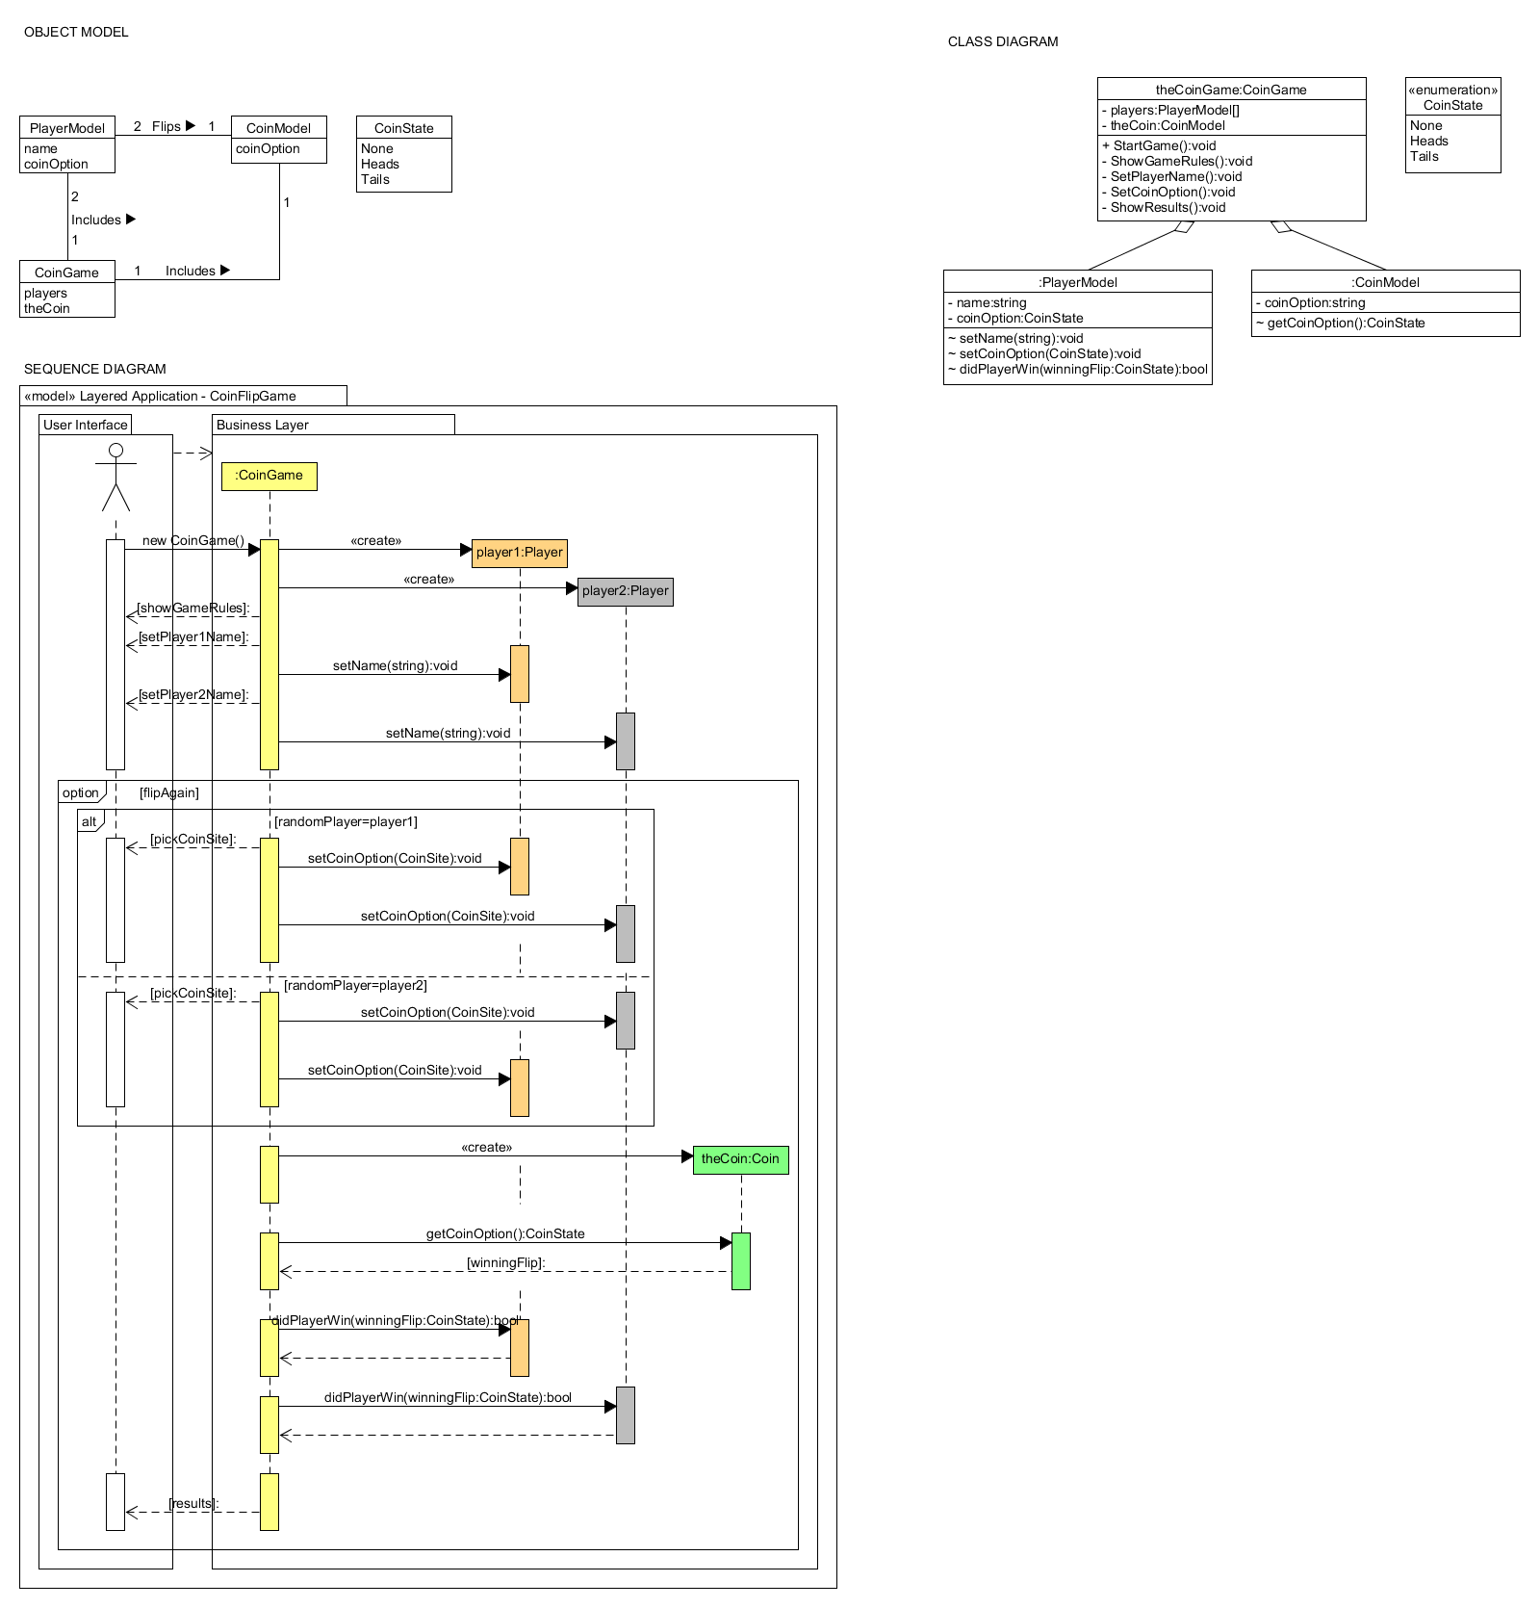

**SEQUENCE DIAGRAM**



**CLASS DIAGRAM**

